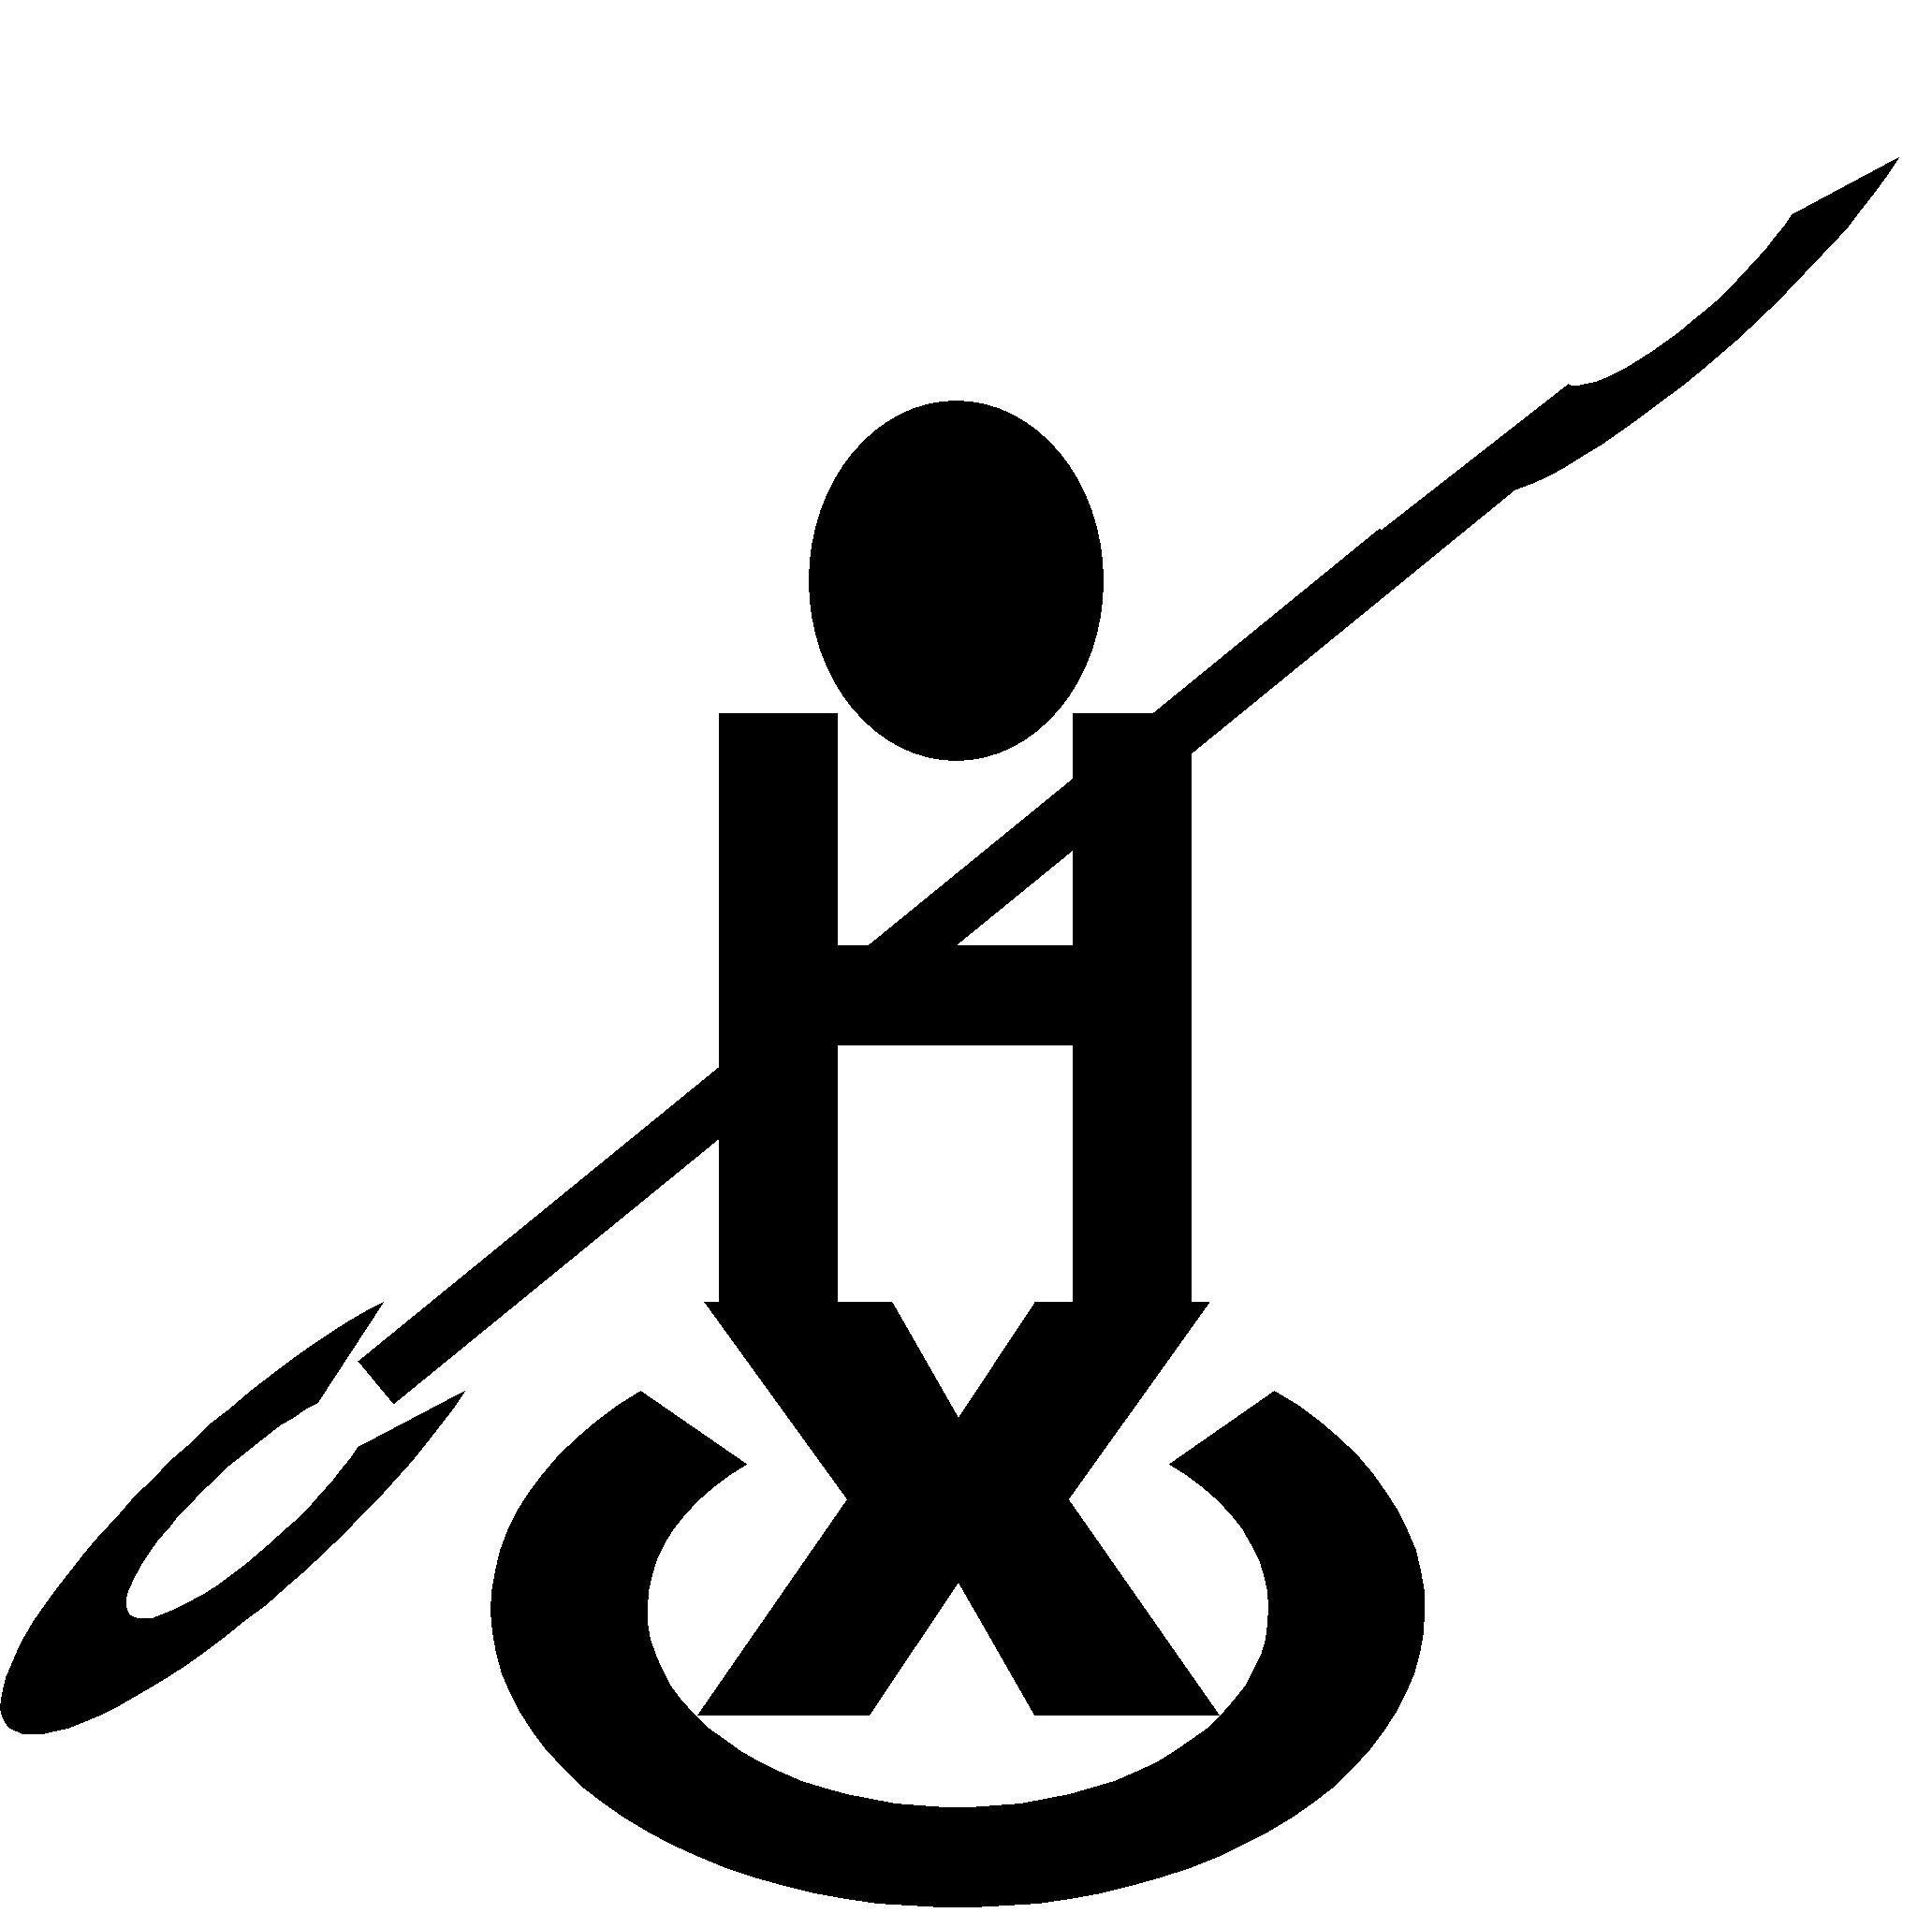

Halifax Canoe Club

Club Clothing 2024

We are planning to order some club clothing – please complete and return this form to place an order. Payment will be requested when we place the order.
- Polo shirts are navy blue with the logo embroidered on the left breast in white.
- T-shirts (in standard and ladies) – navy blue with embroidered logo on left breast in white (in standard and ladies)
- Hoodies are navy blue with the logo embroidered on the left breast in white and printed in large size on the back.
Please order by 8th June 2024

Name:

Item | Size | Cost (each) | Quantity | Total
Kids T Shirt | Age 3/4 | £7.00
Kids T Shirt | Age 5/6 | £7.00
Kids T Shirt | Age 7/8 | £7.00
Kids T Shirt | Age 9-11 | £7.00
Kids T Shirt | Age 12/13 | £7.00
Kids Hoodie  Approximate chest size in inches | Age 3/4 | £19.00
Kids Hoodie  Approximate chest size in inches | Age 5/6 | £19.00
Kids Hoodie  Approximate chest size in inches | Age 7/8 | £19.00
Kids Hoodie  Approximate chest size in inches | Age 9-11 | £19.00
Kids Hoodie  Approximate chest size in inches | Age 12/13 | £19.00
Adults Hoodie  Approximate chest size in inches | XS (34”) | £26.00
Adults Hoodie  Approximate chest size in inches | XS (36”) | £26.00
Adults Hoodie  Approximate chest size in inches | M (38-40”) | £26.00
Adults Hoodie  Approximate chest size in inches | L (42-44”) | £26.00
Adults Hoodie  Approximate chest size in inches | XL (46”) | £26.00
Adults Hoodie  Approximate chest size in inches | 2XL (48”) | £26.00
Adults Polo Shirt  Approximate chest size in inches | XS (36/88”) | £11.00
Adults Polo Shirt  Approximate chest size in inches | S (38/40”) | £11.00
Adults Polo Shirt  Approximate chest size in inches | M (40/42”) | £11.00
Adults Polo Shirt  Approximate chest size in inches | L (42/44”) | £11.00
Adults Polo Shirt  Approximate chest size in inches | XL (44/46”) | £11.00
Adults Polo Shirt  Approximate chest size in inches | 2XL (46/48”) | £11.00
Adults T shirt (standard)  Approximate chest size in inches | S (34/36”) | £9.00
Adults T shirt (standard)  Approximate chest size in inches | M (38”) | £9.00
Adults T shirt (standard)  Approximate chest size in inches | L (40/42”) | £9.00
Adults T shirt (standard)  Approximate chest size in inches | XL (44/46”) | £9.00
Adults T shirt (standard)  Approximate chest size in inches | 2XL (48/50”) | £9.00
Adults T shirt (ladies)  Approximate dress size | S (8-10) | £9.00
Adults T shirt (ladies)  Approximate dress size | M (10-12) | £9.00
Adults T shirt (ladies)  Approximate dress size | L (12-14) | £9.00
Adults T shirt (ladies)  Approximate dress size | XL (14-16) | £9.00
Adults T shirt (ladies)  Approximate dress size | 2XL (18-20) | £9.00
Total

Return forms asap to: Les Ford– ideally by email (coaching@halifaxcanoe.org.uk)

