Club Slalom weekend
Thanks for volunteering to help at our club slalom. This is the first time most of you will have helped at a slalom, so this information is to get everyone up to speed with the basics. While it may seem lengthy, please have a read through so you know what will be happening. Also have a look at the provisional volunteer teams so you know what I’m looking for you to do (and what kit you might need).
The aim of the weekend is to provide a fun entry level slalom for everyone, and you’ll see that paddlers will come quite a way for a race (north Wales, midlands etc).
Currently we have very few entries, but that is not unusual at this level of event. (If you want to have a go in the race, see the details below).
There is also information on the basic camping available on site.
We will have a café running throughout each day. Tea/coffee will be free to volunteers – please bring a thermal mug to cut down on the number of disposable ones used.
Getting there:
Sheffield CC’s site is tucked away off the A6102 at Oughtibridge – its marked on Google Map see https://maps.app.goo.gl/T9nkETq6tGVNg7gK9 or what3words use: launch.spots.spike

On Oughtibridge’s one way loop, turn into Forge Lane, then first right which takes you on to the track behind the houses and through to canoe and football club.
Please drive slowly along the track as there are often children playing along here.
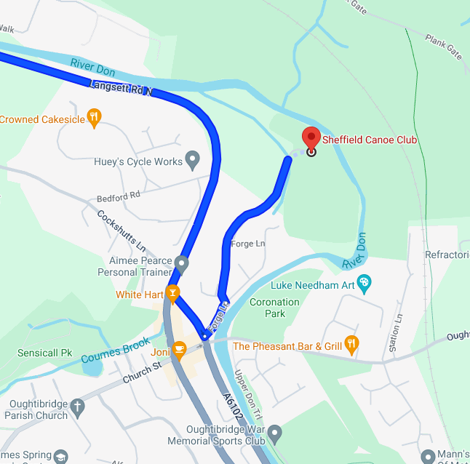

Plan for the weekend
Friday
We’ll meet up on site at 1pm. We need to build the slalom course, set up gazebo’s, run out communication wires for judges and timing. We’ll need some people in wet kit to pull ropes across the river for the slalom gates (you can easily wade across). There’s also a possibility that we might have to move the odd rock out of the way on the course.
Saturday
We need to finish setting up – café, race control and entries tent, put out and test headsets for communications, get race paperwork/clipboards etc set up.
We’ll need to be taking entries and getting these onto the computer.
We also need to make sure all the jobs on our rota are covered and ensure that those doing start/finish and control are trained up on the systems they are using.
If we can be on site to start doing that from 8:30am please.
The racing programme is:
- Entries being taken up until 10:00
- Free practice up until 10:00 (paddlers provide own safety cover)
- 10:00 am – ‘full runs’ practice ** water safety team in place on river
- 11:00 – Start racing (1st runs) ** water safety team in place on river
- 12:00/12:30 ** – lunch break (no safety team in place)
- 13:30** – start racing (2nd runs) ** water safety team in place on river
- 15:00** - Team race (1 run) – that’s teams of 3 boats racing the course!** water safety team in place on river
- 15:30** – Prize giving, then change course (& put some kit away for overnight)
- As soon as the course is change there is free practice for Sunday (paddlers provide own safety cover)
** these timings are guestimates as it depends on the number of entries (and if the communication system has any wobbles!)
Entries for teams will be open until lunchtime on Saturday.

Saturday Evening
Once the racing has finished, we’ll need to change the course for Sunday’s racing – just a few gates – and we’ll do this as soon as we can after prize giving, so those that want to can get on and practice in the evening.
The suggestion is that those staying over have a club BBQ in the evening – there’s a gas bbq there, so bring your own food and drink!

Sunday
This is a repeat of Saturday, with the same timings. However, there will be fewer entries to take and not as much to set up. We won’t have a teams race, and at the end of the racing it is ‘all hands on deck’ to take everything down and pack it away.

Oughtibridge Camping Arrangements
There is basic camping on site and we need to observe the following:
- Camping will be available from Friday afternoon until the end of the event on Sunday.
- There is no electric hook-up available.
- There is a water tap on site, which you are welcome to use. Due to the position of the tap, it is not possible to fill up a campervan/motorhome.
- Please make sure you camp with appropriate distance between yourself and other people.
- There are toilets available on site, however please do not empty chemical toilets into these.
- Please do not pet/feed the ponies/sheep who are in an adjoining paddock.
- No fires please.
- We have no rubbish collection, please take your rubbish home with you.
We will not be charging for camping, however we will be accepting any donations you may wish to give.

Taking part in the Slalom race.
This is a Division 3 and 4 race – unless you have paddled slalom before (ever) in Div 3 or above you’ll race in Div 4.
There are canoe and kayak classes for men and women – and age group prizes within those (depending on numbers racing). There is also a C2 class – two people in a canoe (we’ll need to take the club C2’s if you want to try that – so let me know).
Assuming most people will opt for K1, you can use any kayak you want (you need to bring one). You get 2 timed runs down the course and penalties are added to your time for any gates you miss or go through the wrong way (50secs) or touch (2secs). You count your best run. Don’t worry about the racing, just think of it as a challenge, have fun, and try to improve over the 2 runs.
It is a separate race each day.
The entry fee for Div 4 is £7 per entry (so £14 for both days). If you are Paddle UK member, bring your membership number, if you aren’t a member the club’s affiliation insurance will cover this at Div 4.
We’ll have people that can give you hints and tips on doing the course. There will be others that are complete new to this too.

Thanks
Les
Volunteer list / provisional roles
Hopefully we can have enough people to give people chance to swap over to take breaks or have time to race. There’s room for more volunteers and if you’re not keen on your provisional role we can swap things about on the weekend.

The only ‘wet’ job is on water safety – who will be on the bank at key positions in white water paddling kit ready to go in the water to do rescues or help anyone who gets stuck. There’s no need for boats as all of the river can be waded.

Organiser & Welfare Officer – Les
Event Safety Officer - Chris Hickling
Volunteer Organiser – Sarah Ford
Entries (Sat and Sun am) Stuart & Jayne Vidler
Water Safety team – Chris Hickling, Al Benson, Dave Spencer, Steve Smith, Steve Smith (2 of them!)
Start finish team (bankside) – Bob Lawler, Ian Macadie, Jonathon Quarmby, Mike Highley
Results/timing team (inside) – Stuart Vidler, Jayne Vidler, Liane Hickling Rosie Lonnon, Les
Café team – Nicola Rushworth, Helen Roberts

